Project Design Phase-II
Data Flow Diagram & User Stories

Date | 08 October 2026
Team ID | 9100Quadra
Project Name | Auto Ticket Classification Using ServiceNow Flow Designer
Maximum Marks | 4 Marks

Data Flow Diagrams:
A Data Flow Diagram (DFD) shows how data enters and leaves the system, what changes the information and where data is stored. In this project, the caller's incident text enters the system, the Flow Designer flow evaluates it, and the updated category is stored back in the Incident Workflow table.
Example: (Level 1)
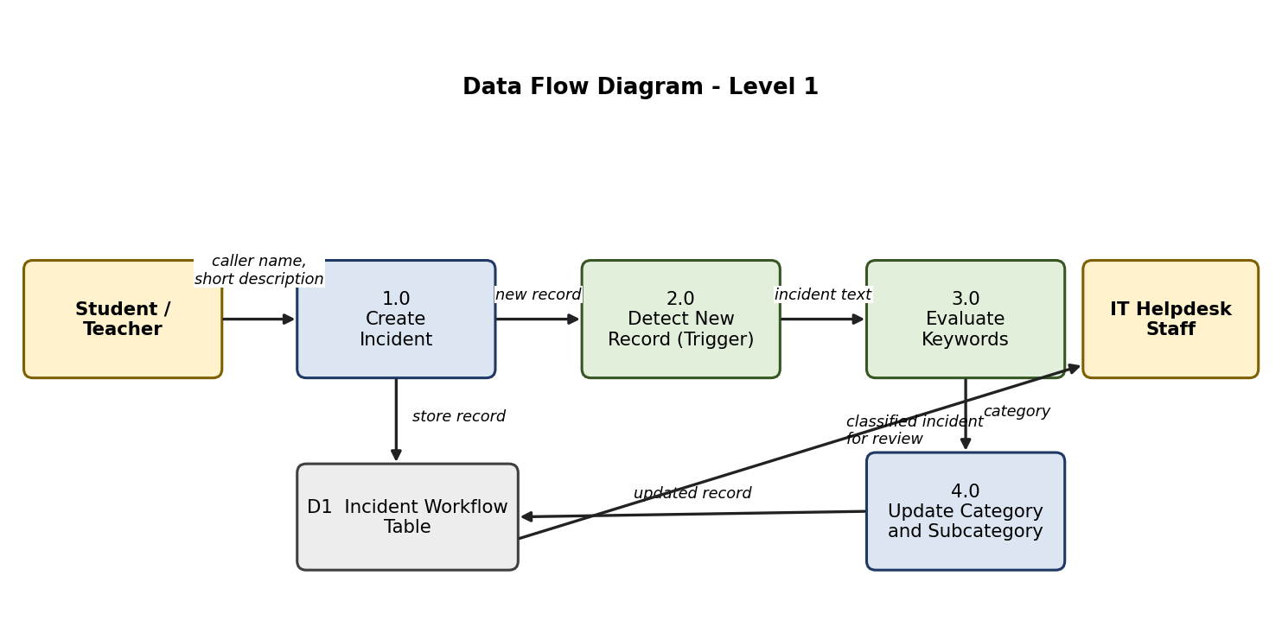

User Stories
Use the below template to list all the user stories for the product.
User Type | Functional Requirement (Epic) | User Story Number | User Story / Task | Acceptance criteria | Priority | Release
Project Team Member | Requirement Analysis & Planning | USN-1 | As a team member, I document the business use case and create the Project Update Set. | Business requirements are recorded and the update set is set as current | High | Sprint-1
Caller (Student / Teacher) | Incident Creation | USN-2 | As a caller, I can create an incident by entering my name and a short description. | Incident is saved in the Incident Workflow table | High | Sprint-1
Administrator | Backend Configuration | USN-3 | As an administrator, I can maintain Category and Subcategory choices with dependency between them. | Subcategory list changes with the selected Category | High | Sprint-1
System (Flow Designer) | Automatic Classification | USN-4 | As the system, I start the flow when a new record is created with an empty Category. | Flow runs once for each new record | High | Sprint-1
 |  | USN-5 | As the system, I assign Category and Subcategory based on keywords in the Short Description. | Wi-Fi/Network, Projector, Password/Login and Slow/Hanging records are classified correctly | High | Sprint-1
Caller (Student / Teacher) | Incident Creation | USN-6 | As a caller, I do not have to choose a category or subcategory. | Category and Subcategory are filled after submission | High | Sprint-2
IT Helpdesk Staff | Review | USN-7 | As helpdesk staff, I can see incidents that are already classified. | Category and Subcategory are visible in the list view | Medium | Sprint-2
 |  | USN-8 | As helpdesk staff, I can classify manually any incident for which no keyword matched. | Unmatched incident keeps Category empty and can be edited | Medium | Sprint-2
Administrator | Testing & Deployment | USN-9 | As an administrator, I can validate the flow using test scenarios for each keyword rule. | Each scenario gives the expected Category and Subcategory | High | Sprint-2
 |  | USN-10 | As an administrator, I can set the update set to Complete and export it as XML. | Update set state is Complete and the XML file is downloaded | Medium | Sprint-2

